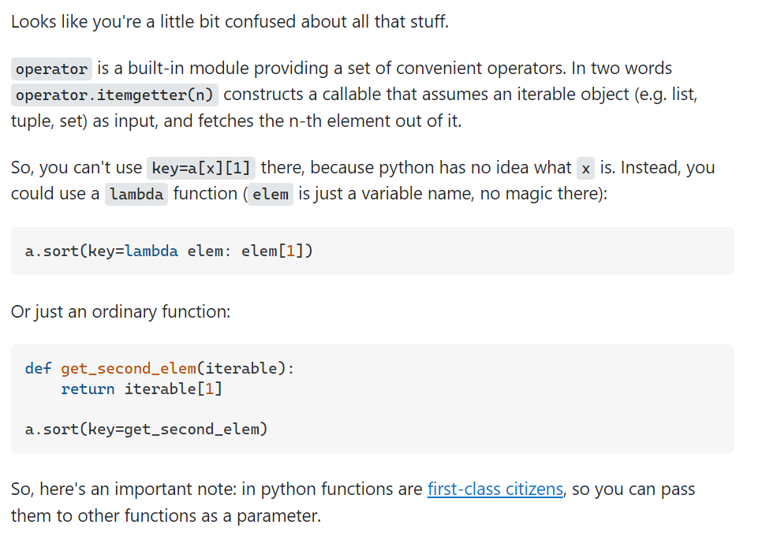

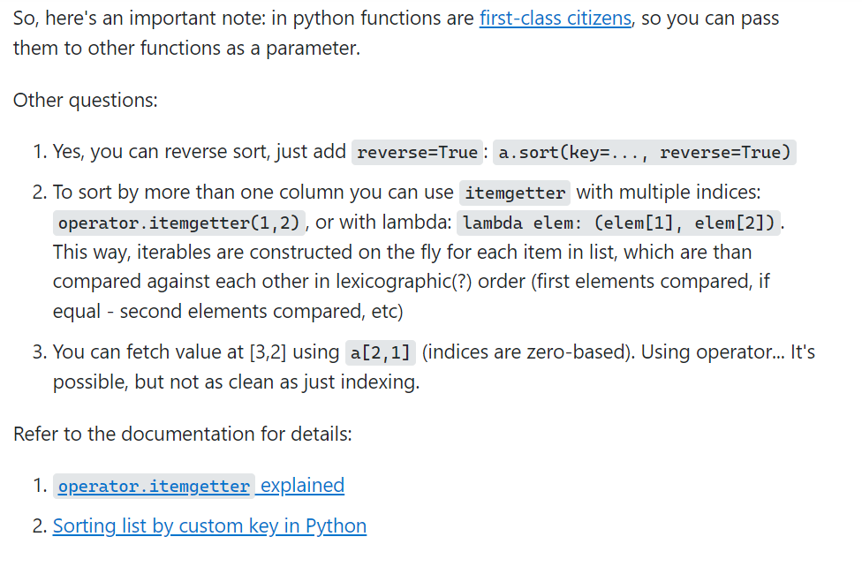

1. [operator.itemgetter explained](https://docs.python.org/3/library/operator.html#operator.itemgetter)
2. [Sorting list by custom key in Python](https://wiki.python.org/moin/HowTo/Sorting/#Key_Functions)

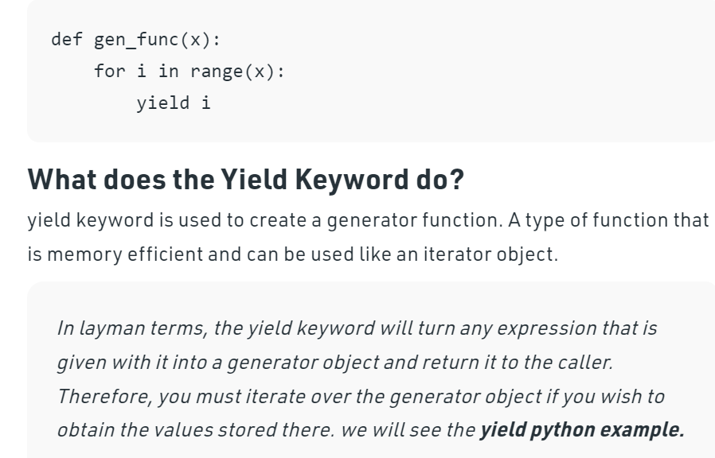

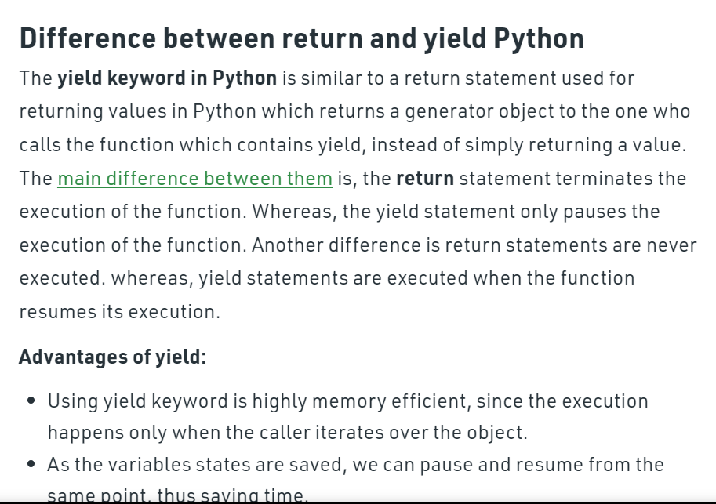

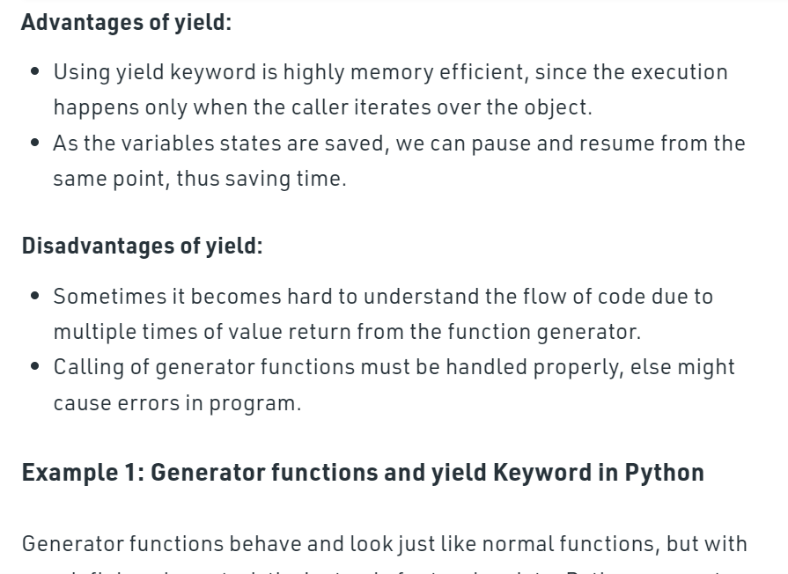

Dictionary in Python is an unordered collection of data values, used to store data values like a map, which unlike other Data Types that hold only single value as an element, Dictionary holds key : value pair.In Python Dictionary, items() method is u...

# Python program to show working

# of items() method in Dictionary

# Dictionary with three items

Dictionary1 = { 'A': 'Geeks', 'B': 4, 'C': 'Geeks' }

print("Dictionary items:")

# Printing all the items of the Dictionary

print(Dictionary1.items())